1. Poisson Distribution
The Poisson distribution is a discrete probability distribution that expresses the probability of a given number of events occurring in a fixed interval of time, if these events occur with a known average rate and independently of each other. It can also be used for the number of events in other specified intervals such as distance, area or volume.

Khan Academy videos on Poisson Processes
Part 1: http://www.youtube.com/watch?v=3z-M6sbGIZ0
Part 2: http://www.youtube.com/watch?v=Jkr4FSrNEVY

Optional video:
http://www.youtube.com/watch?v=8x3pnyYCBto

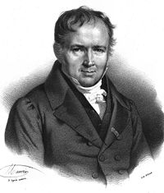
Siméon Poisson (1781-1840)

Many or most applications of Poisson distributions involve studying the number of events that occur in a fixed time period. However the concept generalizes to other applications, such as the frequency of defects in a region of some material. Generically it applies to studying how many events occur in an area of opportunity of fixed size.

Examples of Poisson Processes

No. of phone calls arriving at a call center within a minute
No. of photons arriving at a telescope
No. of mutations on a strand of DNA per unit length
No. of customers arriving at an airline ticket counter
No. of cars arriving at a traffic light
No. of viruses in 1 ml of blood

Assumptions of a Poisson Process

(1) Arrivals/events are temporally or spatially distinct. They occur one-at-a-time, not simultaneously, or in different subareas of observation.

(2) The probability of an arrival or event occurrence is constant.

(3) The probability of each arrival or event is independent of all other arrivals/events.

The Poisson probability distribution is characterized by only one parameter, λ = the average number of events per area of opportunity.

X = 0,1,2,...,

Example Suppose the number of flaws in a 100–foot roll of paper is a Poisson random variable with λ = 10. Then the probability that there are eight flaws in a 100-foot roll is:

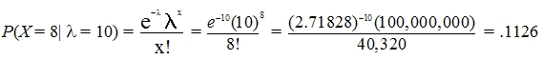

The probability of seven flaws in a 50-foot roll is:

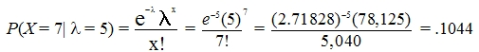

Calculating the Poisson distribution in Excel:

POISSON(x, mu, cumulative)

x = No. of events,
mu = Average arrival/event rate (λ)
cumul = 0, noncumulative distribution
cumul = 1, cumulative distribution

Example: POISSON(8, 10, 0) = 0.112599032

Mean and the Standard Deviation of a Poisson Distribution

μ_{x} = λ

Example 100-foot roll:

μ_{x} = λ = 10 = $\sqrt{\text{10}}$ = 3.16

Read pp. 167–171, Prob 4.40, (a) and (c) only.

2. Probability Distributions and Probability Density Functions

Continuous random variables are variables for which any value within a specified range can occur.

Discrete Probability Distribution

Example: Pr(X = x), x = 0, 1, 2, 3, 4, 5

X = variable
x = some specific value of X
0, 1, 2, … = possible value of x

Mean and Variance of a Discrete Probability Distribution

Example: We could consider raw data:

X: 0, 0, 1, 1, 1, 1, 1, 2, 2, 2, 2, 2, 2, 3, 3, 3, 3, 4, 4, 4, 5, 5

$\overline{X}$= 2.32
σ²= 2.035

Or, we could express the same information as a frequency distribution (or relative frequency distribution = probability distribution):

Frequency Distribution Probability Distribution
Value  x | Frequency  f(x) | Relative  Frequency  p(x)
0 | 2 | 0.09
1 | 5 | 0.23
2 | 6 | 0.27
3 | 4 | 0.18
4 | 3 | 0.14
5 | 2 | 0.09
Total | 22 | 1.0

In Lecture 10 we learned that we can compute the mean (expected value) and variance directly from a summary table like that above.

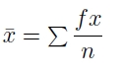
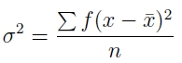

If we apply these formulas to the tabled data we will get the same results as with calcualting the mean and variance directly from the raw data.

So when we talk about finding the expected value and variance of a probability distribution (figure on right), it's basically the same as finding the mean and variance of the raw (unaggregated) variable.

Continuous Probability Distributions

Video: An Introduction to Continuous Probability Distributions
http://www.youtube.com/watch?v=OWSOhpS00_s

Recall what a discrete probability distribution looks like (e.g., binomial distribution)

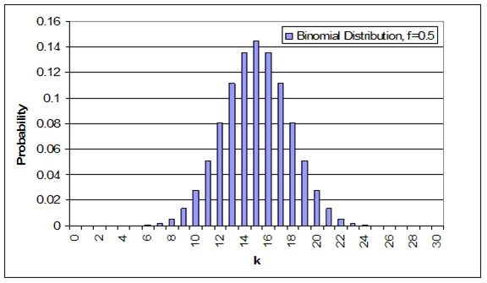

Imagine narrower and narrower x-axis intervals, converging on infinitely narrow intervals: i.e., a probability distribution for a continuous variable.

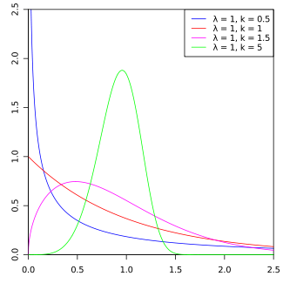

However, because we have infinitely many, infinitely small intervals on the x-axis, the y axis no longer reflects probability (we'll see why shortly). Instead the y-axis is called 'probability density'.

The probability density function of x, f(x) or pdf(x), supplies the probability density (y) for each possible value of x.

In general, for a continuous variable, the probability of x falling between a and b is:

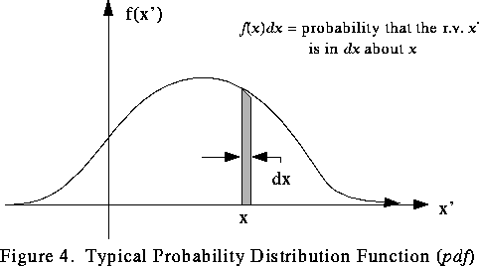

Probability density function is abbreviated as pdf.

The y-axis of a pdf is rescaled so that the total area under the curve (e.g., from –inf to +inf) is 1.0. This means the y-axis height is somewhat arbitrary. It is more or less a scaling factor, needed to assure that the total area under the curve is 1.0.

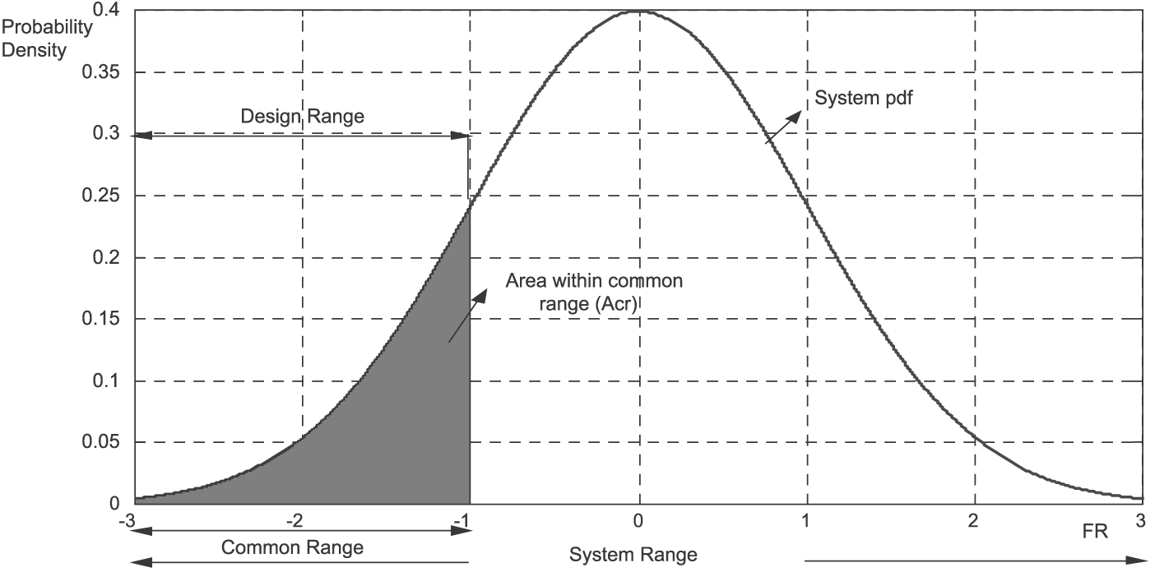

This means that the height of pdf(x) is not the probability of x occurring. It is the probability density of x. However the probability density is proportional to probability.
The ratio of pdf(x1) to pdf(x2) is the same as the ratio of Pr(x1) to Pr(x2).

The cumulative distribution function gives the area (probability) of being less than a given value of x. This function is denoted as F(x) or cdf(x).

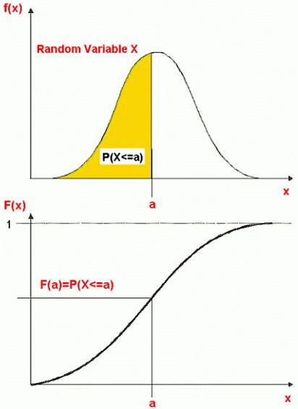

The mean or expected value and variance for a continuous variable:

The uniform (or rectangular) distribution is a pdf where all values of x are equally likely.

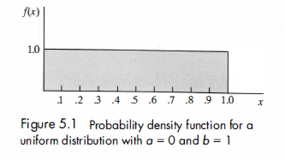

We denote the lower and upper x-axis bounds as a and b, respectively. (Note: a and b here define an entire range of possible values; above they delimited only a specific subrange).

The expected value and variance of a uniform is given by:

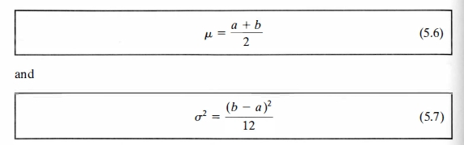

The probability that x falls into a range defined by x_{low} and x_{high} is:

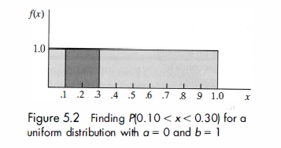

Pr(x_{low} < x < x_{high}) = (x_{high} < x < x_{low}) / (b – a)

Videos

Playlist: Continuous Probability Distributions
http://www.youtube.com/playlist?list=PLvxOuBpazmsPDZGwqhhjE3KkLWnTD34R0

Read pp. 180–183.

